BUG REPORT
This document outlines the detailed report of the bugs identified during the manual execution of a user story. It also includes the screenshots of the issue/s. The intention of this documentation is to be able to replicate the issue by following the provided steps.

ISSUE : #1
Title : Ubiquity logo is missing from the top of the homepage (post login)
Severity : Low
Environment : Test environment. http://13.75.189.136:8081

Steps : Launch the above environment.
: Login with the following credentials
UserName : ubiquity
Password : P@ss123#UbiQuity
: Observe the top left corner of the page.

Actual : Ubiquity logo is not displayed on the top left corner of the page
Expected : Ubiquity logo should be displayed on all the branded pages as per the Acceptance criteria (All pages should be branded with Ubiquity logo.)

Evidence :
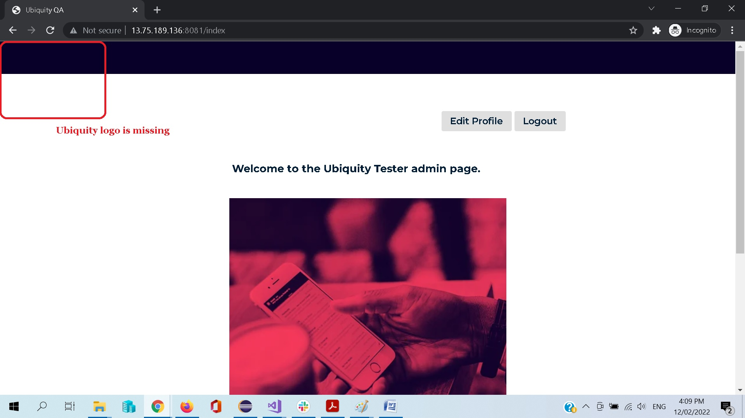

ISSUE : #2
Title : The text on the landing page is missing the ‘Test’ copy from it
Severity : Low
Environment : Test environment. http://13.75.189.136:8081

Steps : Launch the above environment.
: Login with the following credentials
UserName : ubiquity
Password : P@ss123#UbiQuity
: Observe the text above the marketing picture of the company.

Actual : ‘Test’ copy is missing from the welcome text on the landing page
Expected : ‘Test’ copy should be included in the welcome text on the landing page as per the Acceptance criteria (Welcome to the Ubiquity Tester Test admin page.)

Evidence :

